In this lecture, The seventh part of the first module was covered. Which is “Nested loops”

Nested loops basically means one or more loops inside a loop. As we know, Loops are basically a technique to do mundane iteration tasks multiple times. A loop contains 3 parts. Those are,

* **Initialization:** This is the gateway point of a loop. Basically, It’s the point where a loop starts.
* **Condition:** This is basically a controlling technique. If we need to stop a loop or run it for a specific number of times, Then that’s the condition on which the loop is dependent.
* **Increment/Decrement:** According to a situation, We can either make the loop go down from above which is known as “decrease” and the vice versa is known as “increase”.

A nested loop can be of any combination using **FOR** & **WHILE as** many times as needed.

A loop has 3 control statements

* **Break:** Break statement basically breaks out of a loop.
* **Continue:** Control statement sends the code at the top of the loop.
* **Pass:** Pass basically is a neutral or null statement. It basically does nothing as it lets the code pass as it is. It is used to maintain the status quo.

Nested loops are used to make patterns. The combination depends on the pattern.

To control the row, We use the outer loop & To control column, We use the inner loop.

**EG:** Let’s say, We want to make a pattern like this.

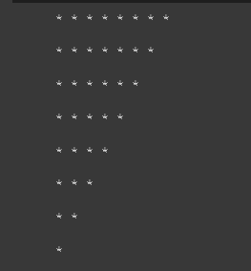

There are 8 rows and maximum 8 columns. So, We will use the outer loop to control the row and inner loop to control the column.

**Code:**

i = 8

j = 8

for k in range(1,j+1,1):

for x in range(1,i+1,1):

print("*", end = ' ')

i -= 1

print('\n')

We used the outer for loop to control the row and inner for loop to control the columns and made this upside down right triangle.

If it were like this,

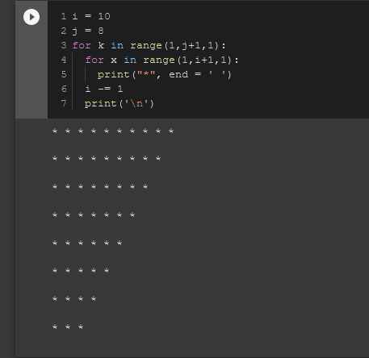

We see that there are **i = 10 columns** and **j = 8 rows**. Outer loop is controlling j, or the row and the inner loop is controlling the i or columns.